import java.lang.*;

public class Main {

public static void main(String[] args)

{

String str1 = "Python";

String str2 = "Tutorial";

System.out.println(str1.substring(1) + str2.substring(1));

}

}

Output:

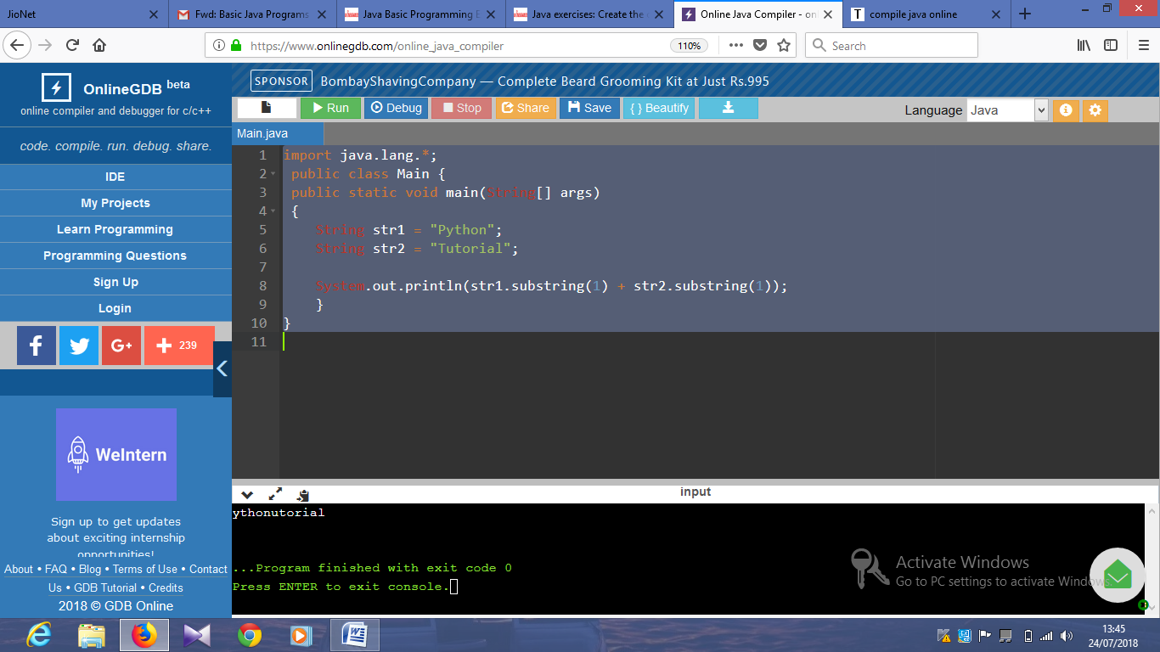

import java.lang.*;

public class Main {

public static void main(String[] args)

{

String str1 = "";

int len = str1.length();

if(len >= 3)

System.out.println( str1.substring(0, 3));

else if(len == 1)

System.out.println( (str1.charAt(0)+"##"));

else

System.out.println("###");

}

}

Output:

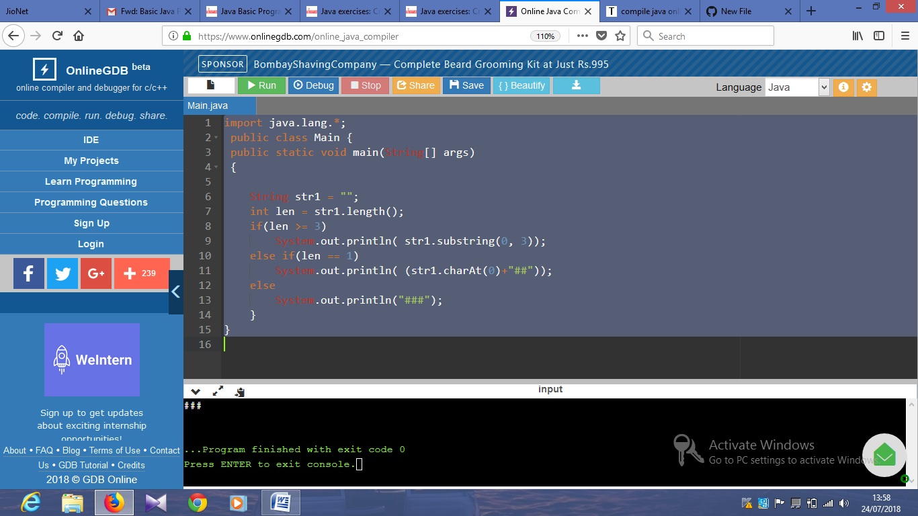

import java.lang.*;

public class Main {

public static void main(String[] args)

{

String str1 = "Python";

String str2 = "";

int length2 = str2.length();

String result = "";

result += (str1.length() >= 1) ? str1.charAt(0) : '#';

result += (length2 >= 1) ? str2.charAt(length2-1) : '#';

System.out.println(result);

}

}

Output:

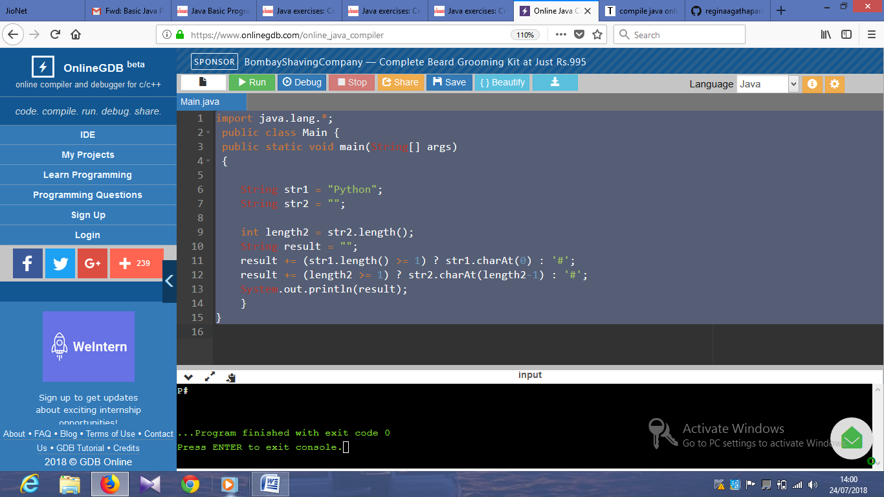

import java.lang.*;

public class Main {

public static void main(String[] args)

{

int[] num_array = {10, -20, 0, 30, 40, 60, 10};

System.out.println((num_array[0] == 10 || num_array[num_array.length-1] == 10));

}

}

Output:

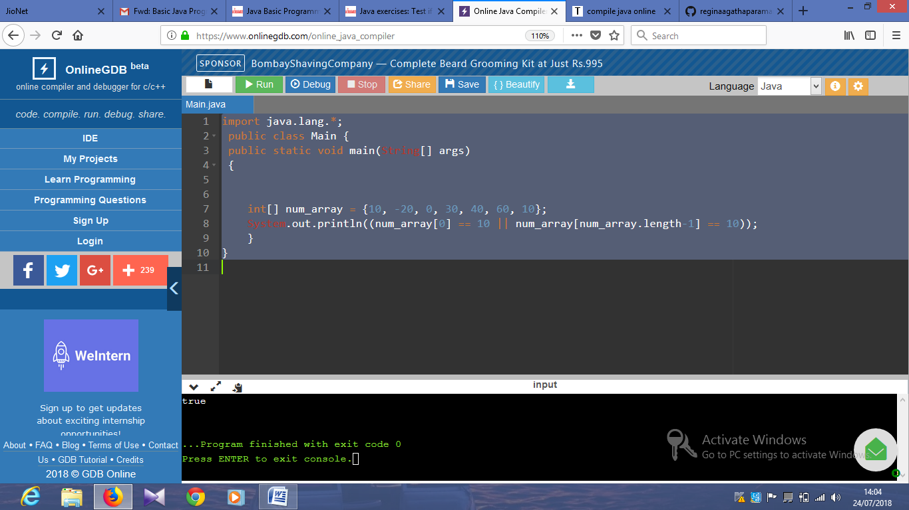

import java.lang.*;

public class Main {

public static void main(String[] args)

{

int[] num_array = {50, -20, 0, 30, 40, 60, 10};

System.out.println (num_array.length >= 1 && num_array[0] == num_array[num_array.length-1]);

}

}

Output:

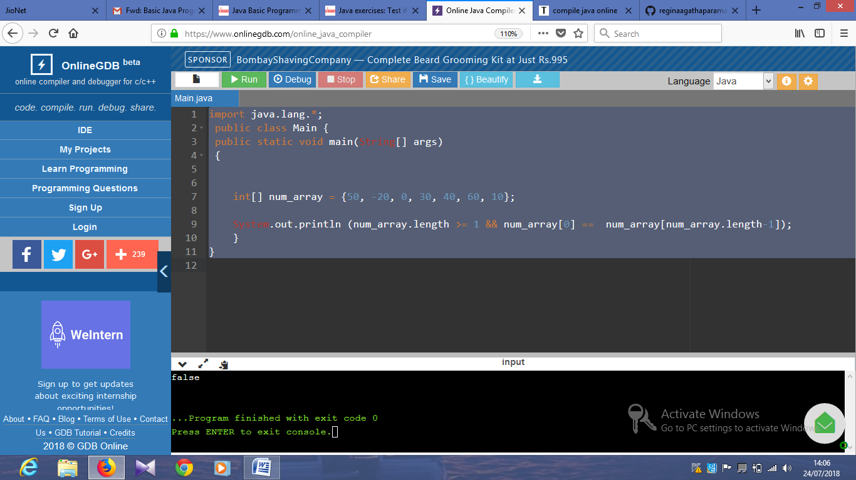

import java.lang.*;

public class Main {

public static void main(String[] args)

{

int[] num_array1 = {50, -20, 0, 30, 40, 60, 12};

int[] num_array2 = {45, 20, 10, 20, 30, 50, 11};

System.out.println(num_array1[0] == num_array2[0] || num_array1[num_array1.length-1] == num_array2[num_array2.length-1]);

}

}

Output:

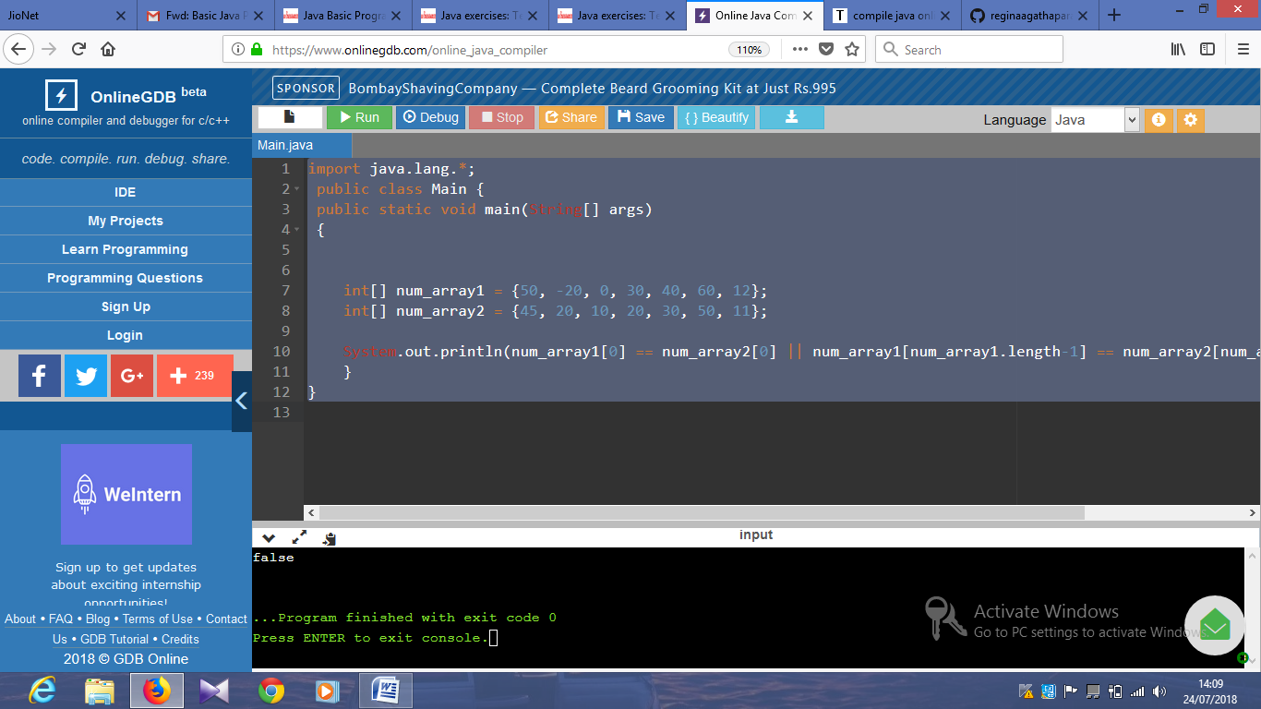

import java.lang.*;

public class Main {

public static void main(String[] args)

{

int[] array1 = {50, -20, 0};

int[] array2 = {5, -50, 10};

System.out.println("Array1: "+Arrays.toString(array1));

System.out.println("Array2: "+Arrays.toString(array2));

int[] array_new = {array1[0], array2[2]};

System.out.println("New Array: "+Arrays.toString(array_new));

}

}

import java.util.Arrays;

public class Main {

public static void main(String[] args)

{

int[] array_nums = {5, 7};

System.out.println("Original Array: "+Arrays.toString(array_nums));

if(array_nums[0] == 4 || array_nums[0] == 7)

System.out.println("True");

else

System.out.println(array_nums[1] == 4 || array_nums[1] == 7);

}

}

Output:

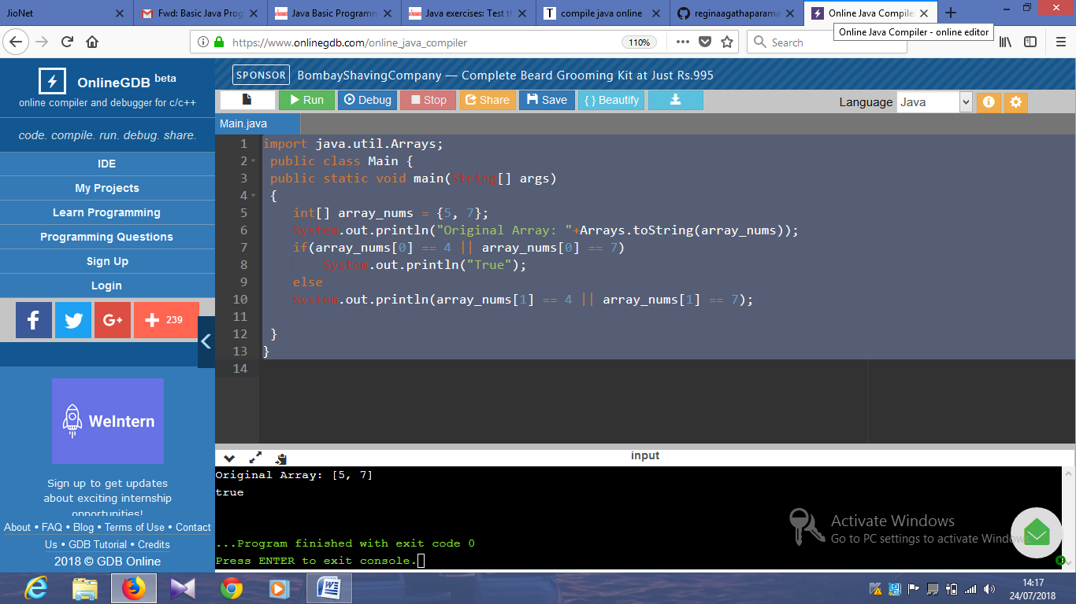

import java.util.Arrays;

public class Main {

public static void main(String[] args)

{

int[] array_nums = {20, 30, 40};

System.out.println("Original Array: "+Arrays.toString(array_nums));

int[] new_array_nums = {array_nums[1], array_nums[2], array_nums[0]};

System.out.println("Rotated Array: "+Arrays.toString(new_array_nums));

}

}

Output:

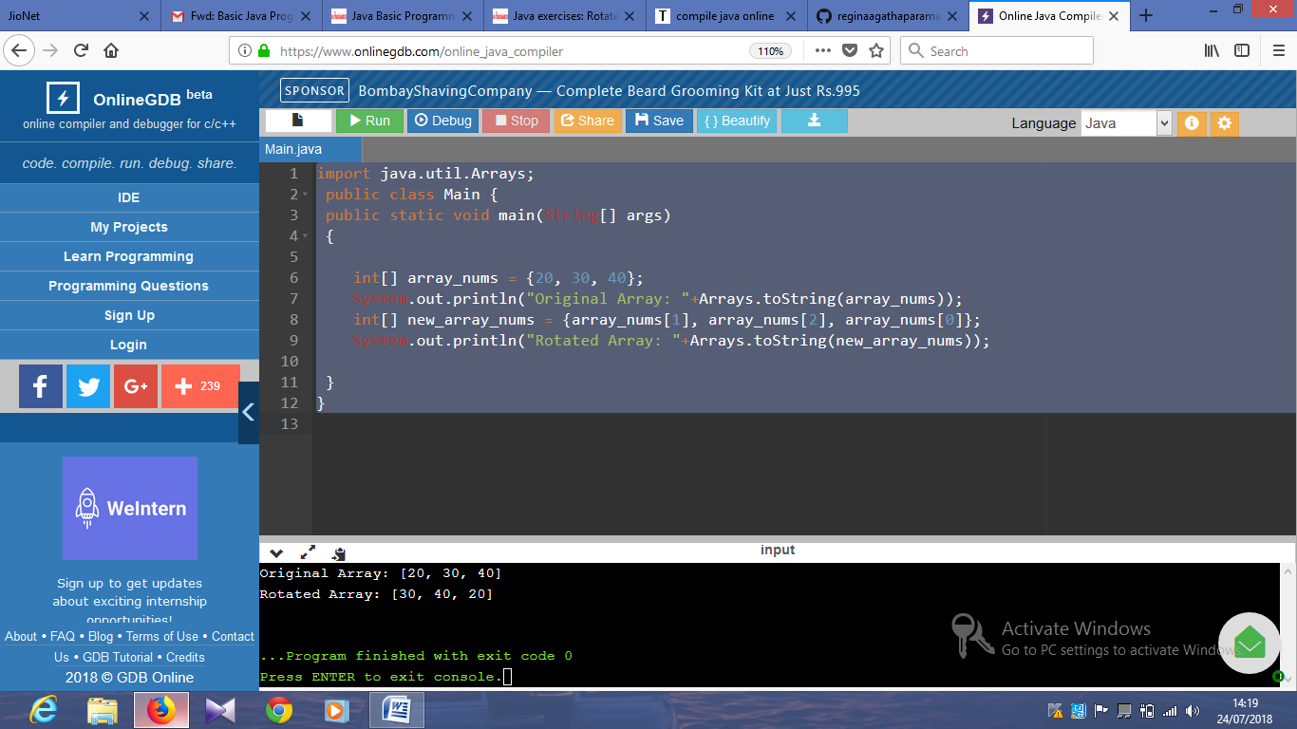

import java.util.Arrays;

public class Main {

public static void main(String[] args)

{

int[] array_nums = {20, 30, 40};

System.out.println("Original Array: "+Arrays.toString(array_nums));

int max_val = array_nums[0];

if(array_nums[2] >= max_val)

max_val = array_nums[2];

System.out.println("Larger value between first and last element: "+max_val);

}

}

Output:

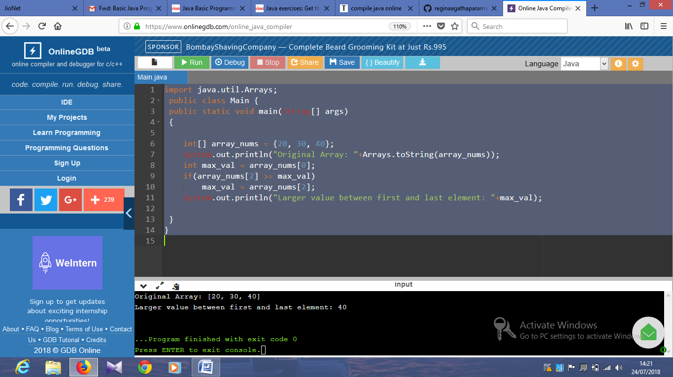

import java.util.Arrays;

public class Main {

public static void main(String[] args)

{

int[] array_nums = {20, 30, 40};

System.out.println("Original Array: "+Arrays.toString(array_nums));

int x = array_nums[0];

array_nums[0] = array_nums[array_nums.length-1];

array_nums[array_nums.length-1] = x;

System.out.println("New array after swaping the first and last elements: "+Arrays.toString(array_nums));

}

}

Output:

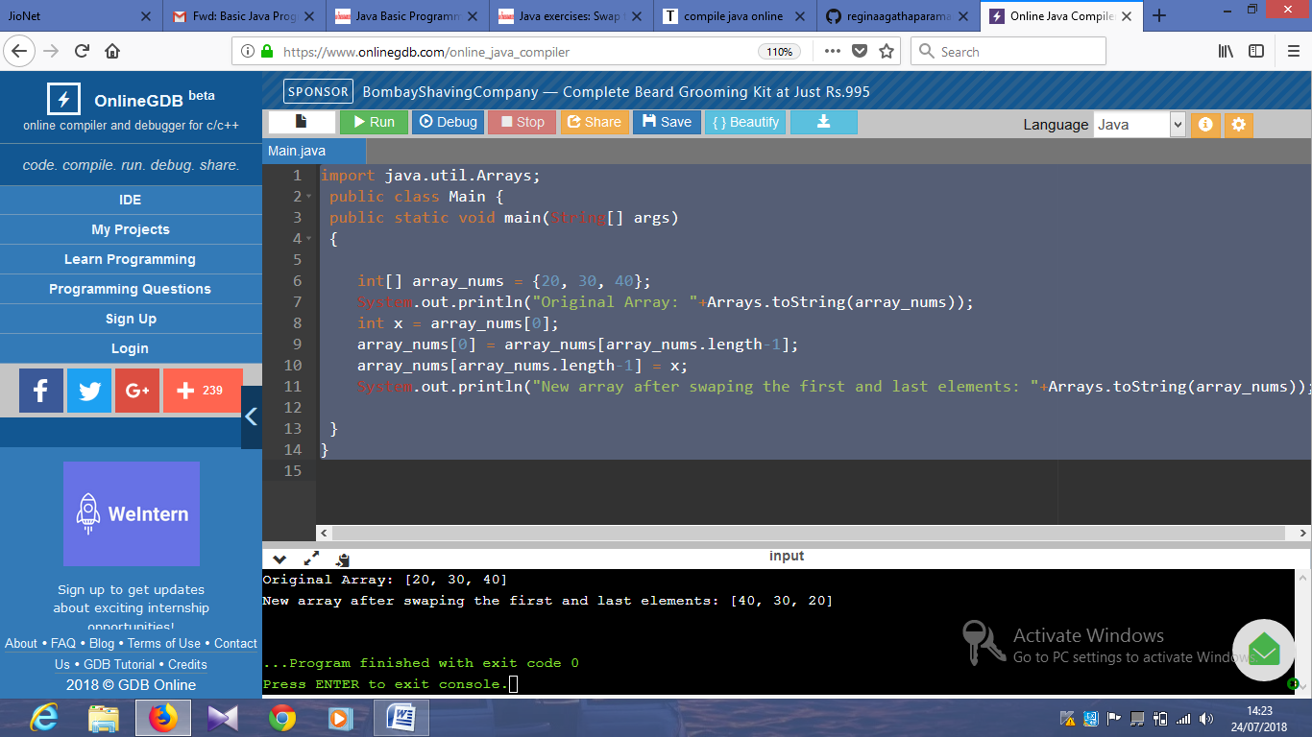

import java.util.Arrays;

public class Main {

public static void main(String[] args)

{

int[] array_nums = {20, 30, 40, 50, 67};

System.out.println("Original Array: "+Arrays.toString(array_nums));

int max_val = array_nums[0];

if(max_val <= array_nums[array_nums.length-1])

max_val = array_nums[array_nums.length-1];

if(max_val <= array_nums[array_nums.length/2])

max_val = array_nums[array_nums.length/2];

System.out.println("Largest element between first, last, and middle values: "+max_val);

}

}

Output:

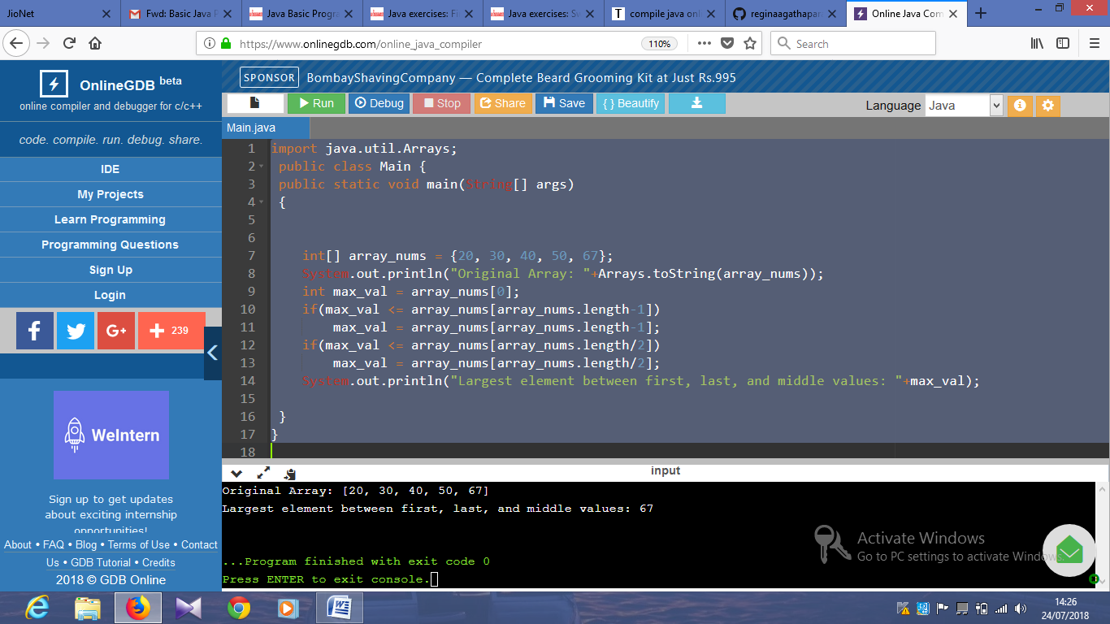

import java.util.Arrays;

public class Main {

public static void main(String[] args)

{

String result = "";

int[] left_array = {1, 3, -5, 4};

int[] right_array = {1, 4, -5, -2};

System.out.println("\nArray1: "+Arrays.toString(left_array));

System.out.println("\nArray2: "+Arrays.toString(right_array));

for (int i = 0; i < left_array.length; i++) {

int num1 = left_array[i];

int num2 = right_array[i];

result += Integer.toString(num1 * num2) + " ";

}

System.out.println("\nResult: "+result);

}

}

Output:

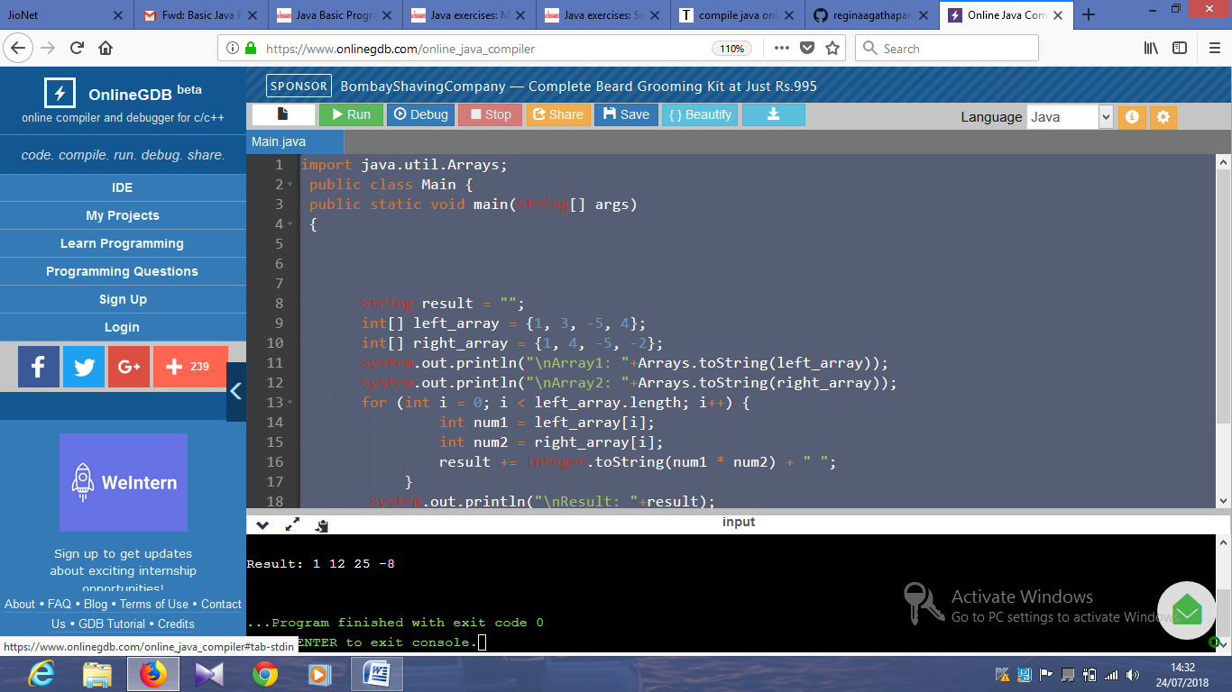

import java.util.Arrays;

public class Main {

public static void main(String[] args)

{

String string1 = "Python";

int slength = 3;

if (slength > string1.length()) {

slength = string1.length();

}

String subpart = string1.substring(string1.length()-3);

System.out.println(subpart + string1 + subpart);

}

}

Output:

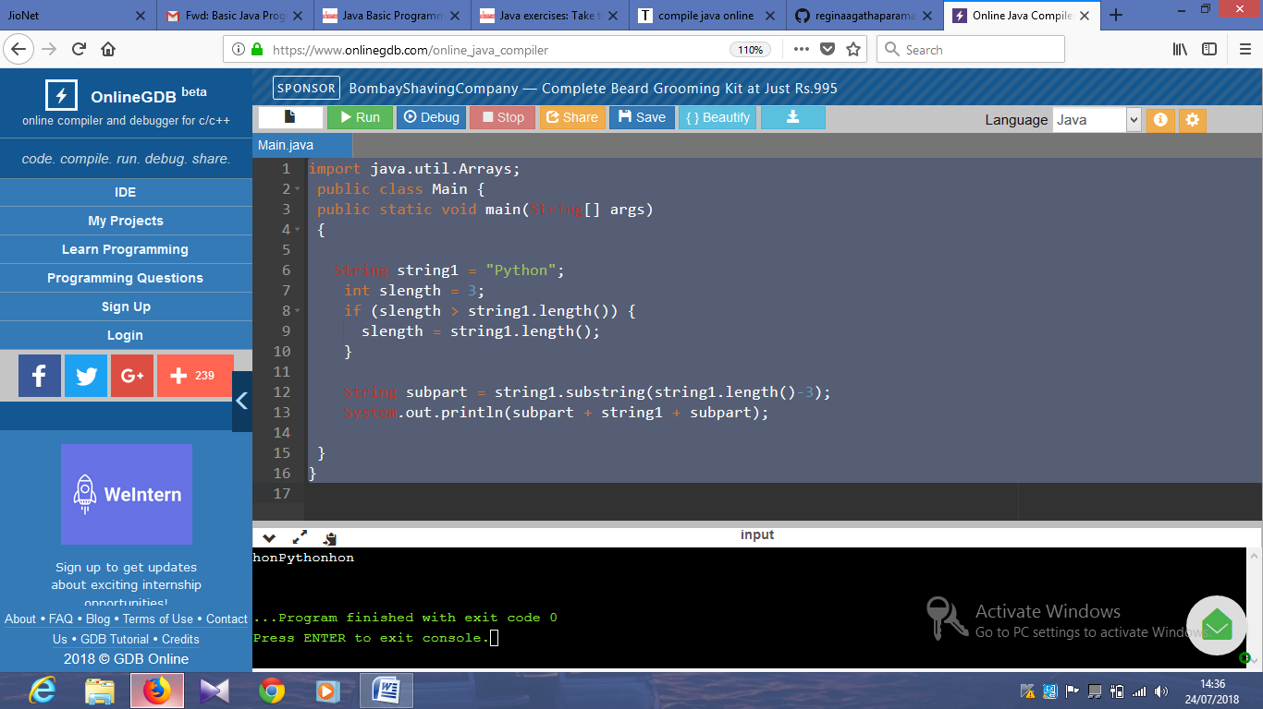

import java.util.Arrays;

public class Main {

public static void main(String[] args)

{

String string1 = "Hello how are you?";

System.out.println(string1.startsWith("Hello"));

}

}

Output:

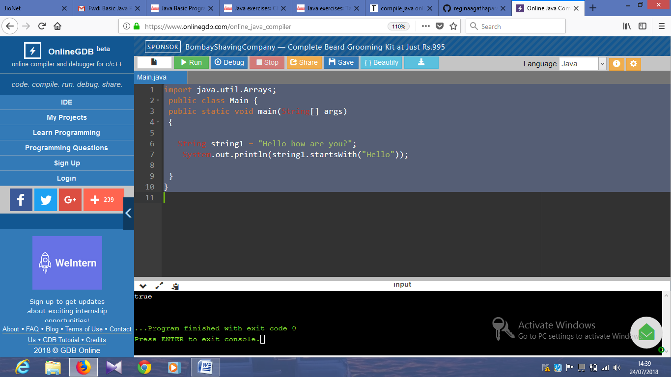

import java.util.Scanner;

public class Main {

public static void main(String[] args) {

int ctr = 0;

Scanner in = new Scanner(System.in);

int n = in.nextInt();

while (n != 1) {

System.out.println(n);

if (n % 2 == 0) {

n = n / 2;

ctr += 1;

}

else {

n = (3 * n + 1) / 2;

ctr += 1;

}

}

System.out.println(ctr);

in.close();

}

}

Ouyput:

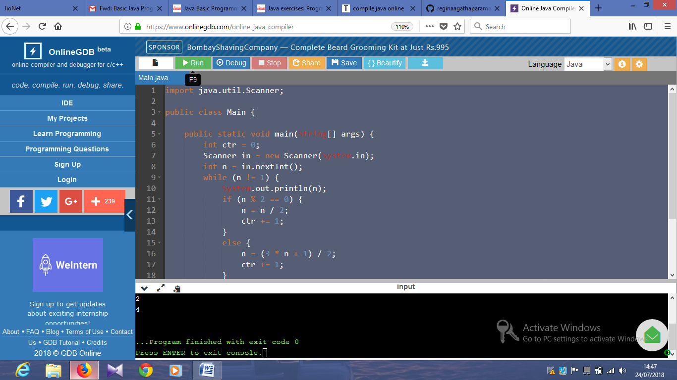

import java.io.*;

public class Main {

public static void main(String[] args) {

BufferedReader br = new BufferedReader(new InputStreamReader(System.in));

try {

int sum = 0;

String str = br.readLine();

char[] numStr = str.toCharArray();

for (int i = 0; i < numStr.length; i ++) {

sum += numStr[i] - '0';

}

System.out.println("Original Number: "+str);

print_number(sum);

} catch (IOException e) {

e.printStackTrace();

}

}

public static void print_number(int n) {

int x; int y; int z;

String[] number = {"zero","one","two","three","four","five","six","seven","eight","nine"};

System.out.println("Sum of the digits of the said number: "+n);

if (n < 10) {

System.out.println(number[n]);

}

else if (n < 100) {

x = n / 10;

y = n - x *10;

System.out.println("In English: "+number[x] + " " + number[y]);

}

else {

x = n / 100;

y = (n - x * 100) / 10;

z = n - x * 100 - y * 10;

System.out.println("In English: "+number[x] + " " + number[y] + " " + number[z]);

}

}

}

Output:

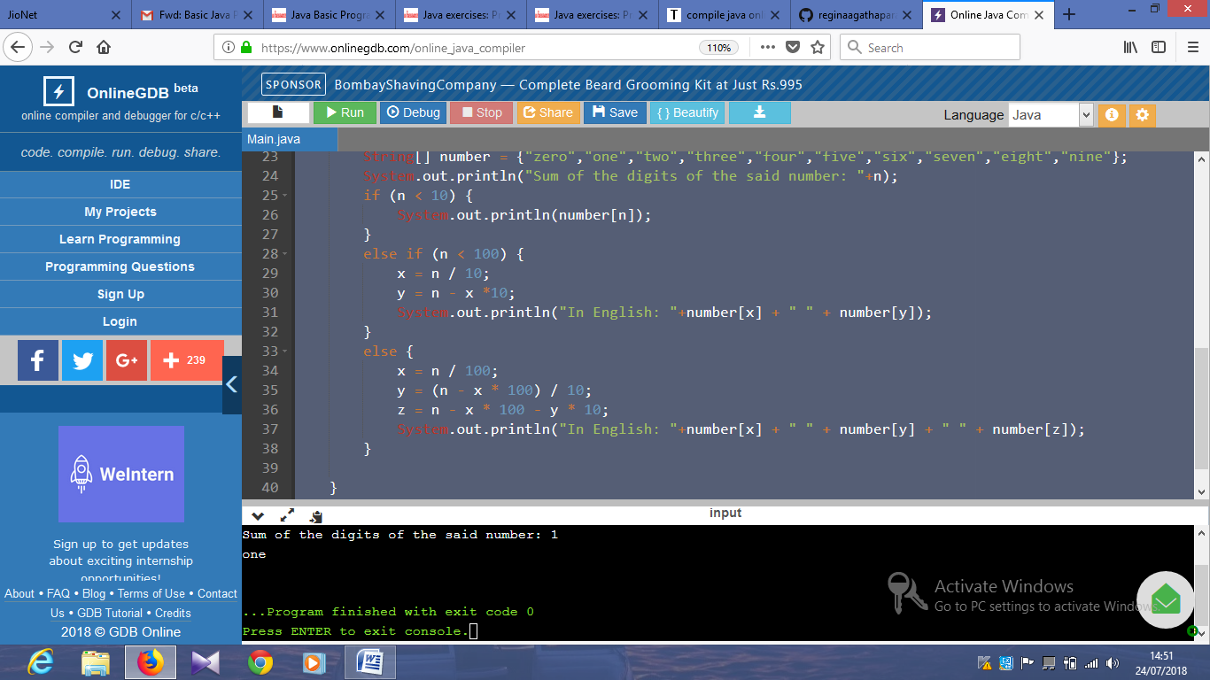

import java.io.*;

public class Main {

public static void main(String[] args) {

System.out.println("\nCurrent system environment:");

System.out.println(System.getenv());

System.out.println("\n\nCurrent system properties:");

System.out.println(System.getProperties());

}

}

Output:

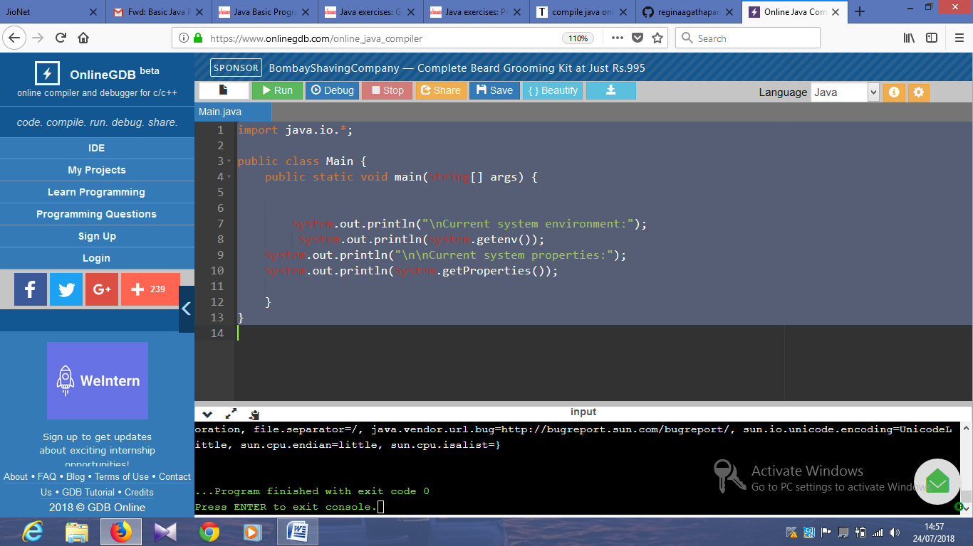

import java.io.*;

public class Main {

public static void main(String[] args) {

System.out.println("System security interface:");

System.out.println(System.getSecurityManager());

}

Output:

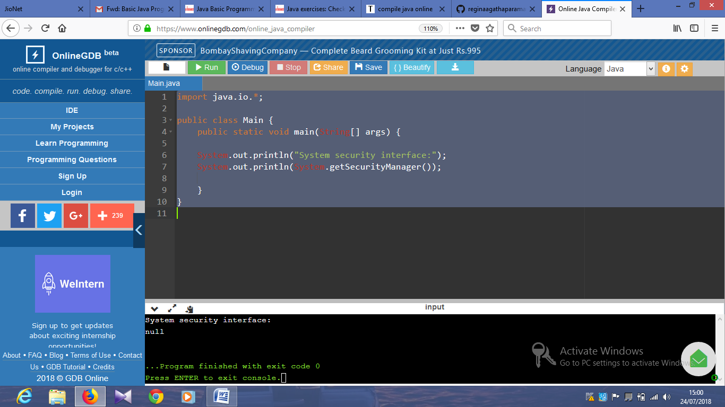

import java.lang.*;

public class Main {

public static void main(String[] args)

{

// gets the value of the specified environment variable "PATH"

System.out.println("\nEnvironment variable PATH: ");

System.out.println(System.getenv("PATH"));

// gets the value of the specified environment variable "TEMP"

System.out.println("\nEnvironment variable TEMP: ");

System.out.println(System.getenv("TEMP"));

// gets the value of the specified environment variable "USERNAME"

System.out.println("\nEnvironment variable USERNAME: ");

System.out.println(System.getenv("USERNAME"));

}

Output:

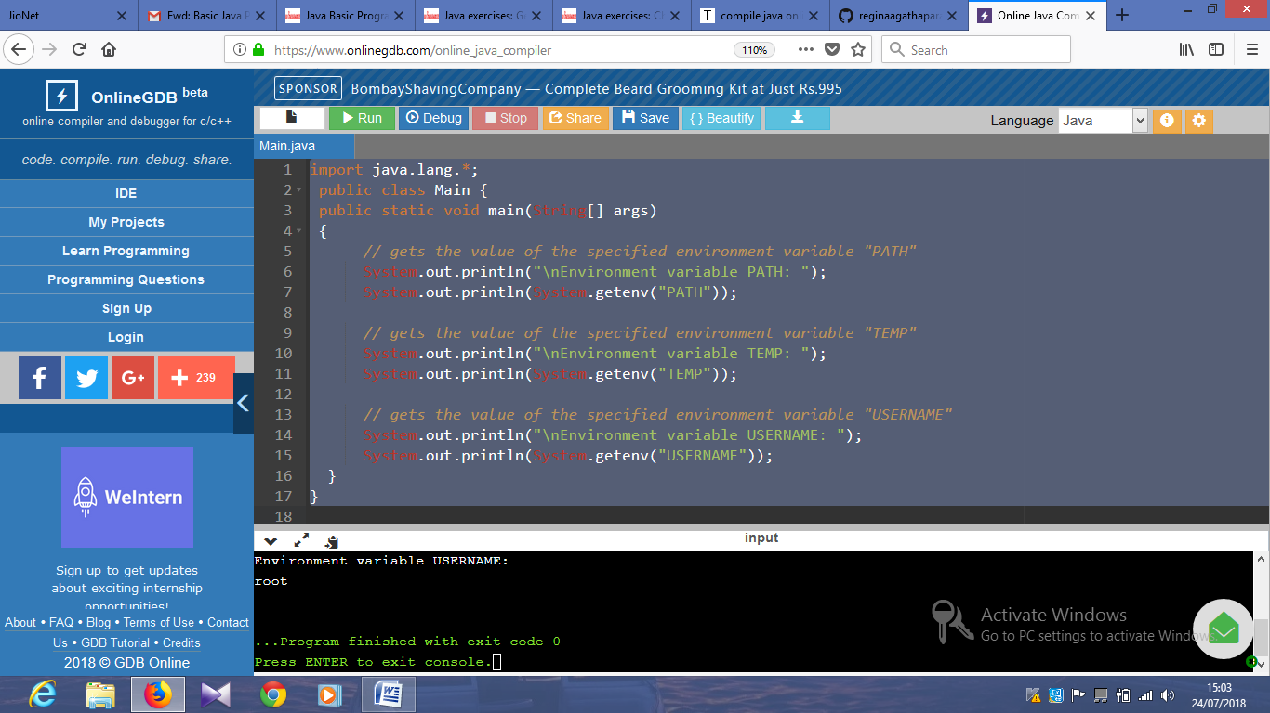

import java.lang.*;

public class Main {

public static void main(String[] args)

{

long startTime = System.nanoTime();

// Sample program

// Display the first 10 natural numbers.

int i;

System.out.println ("The first 10 natural numbers are:\n");

for (i=1;i<=10;i++)

{

System.out.println (i);

}

long estimatedTime = System.nanoTime() - startTime;

System.out.println("Estimated time (in nanoseconds) to get the first 10 natural numbers: "+estimatedTime);

}

}

Output:

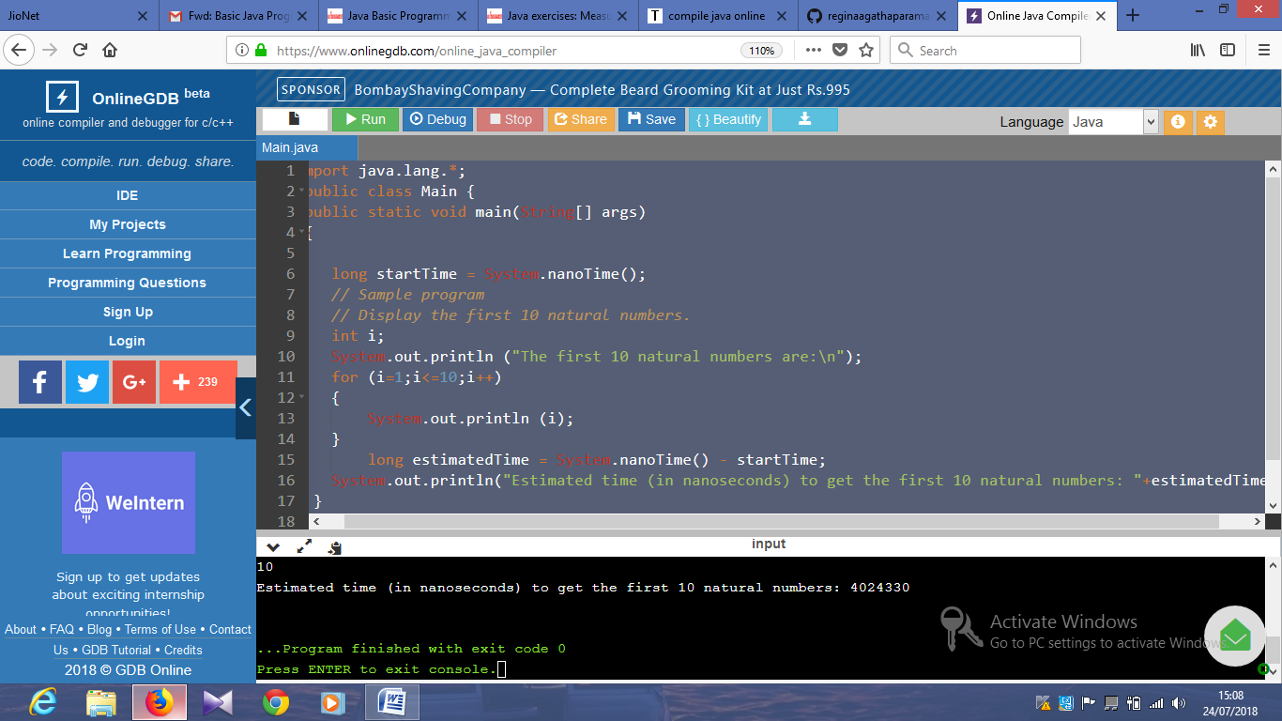

import java.util.*;

public class Main {

public static void main(String[] args)

{

int[] nums = {5, 7, 2, 4, 9};

int ctr_even = 0, ctr_odd = 0;

System.out.println("Original Array: "+Arrays.toString(nums));

for(int i = 0; i < nums.length; i++) {

if(nums[i] % 2 == 0)

{

ctr_even++;

}

else

ctr_odd++;

}

System.out.printf("\nNumber of even elements in the array: %d",ctr_even);

System.out.printf("\nNumber of odd elements in the array: %d",ctr_odd);

System.out.printf("\n");

}

Output:

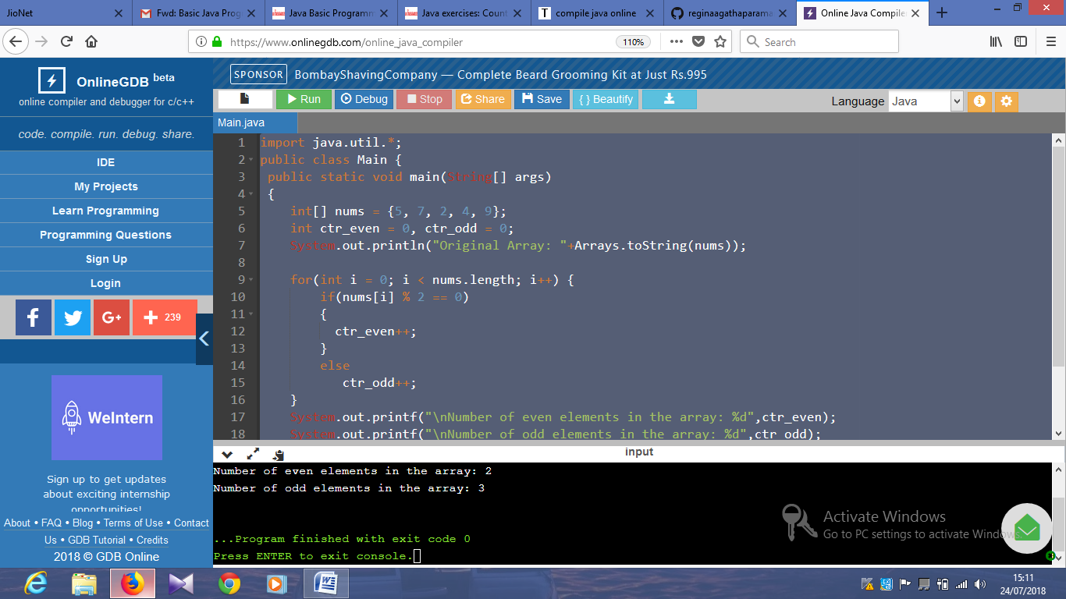

import java.util.*;

public class Main {

public static void main(String[] args)

{

//int[] nums = {10, 10, 2, 4, 9};

int[] nums = {10, 10, 2, 4, 20, 20};

int ctr_even = 0, ctr_odd = 0;

System.out.println("Original Array: "+Arrays.toString(nums));

boolean found1010 = false;

boolean found2020 = false;

for(int i = 0; i < nums.length - 1; i++) {

if(nums[i] == 10 && nums[i+1] == 10)

found1010 = true;

if(nums[i] == 20 && nums[i+1] == 20)

found2020 = true;

}

Output:

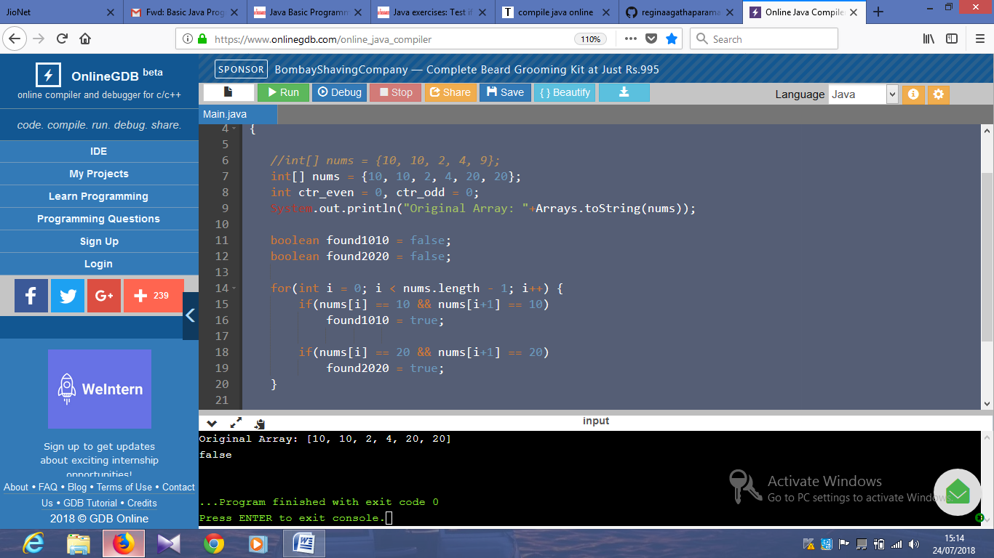

System.out.printf( String.valueOf(found1010 != found2020));

System.out.printf("\n");

}

}

import java.util.*;

public class Main {

public static void main(String[] args)

{

int[] array_nums = {1, 7, 8, 5, 7, 13, 0, 2, 4, 9};

int i = 0;

System.out.println("Original Array: "+Arrays.toString(array_nums));

while(i < array_nums.length && array_nums[i] % 2 == 0)

i++;

for(int j = i + 1; j < array_nums.length; j++) {

if(array_nums[j] % 2 != 0) {

int temp = array_nums[i];

array_nums[i] = array_nums[j];

array_nums[j] = temp;

i++;

}

}

System.out.println("New Array: "+Arrays.toString(array_nums));

}

Output:

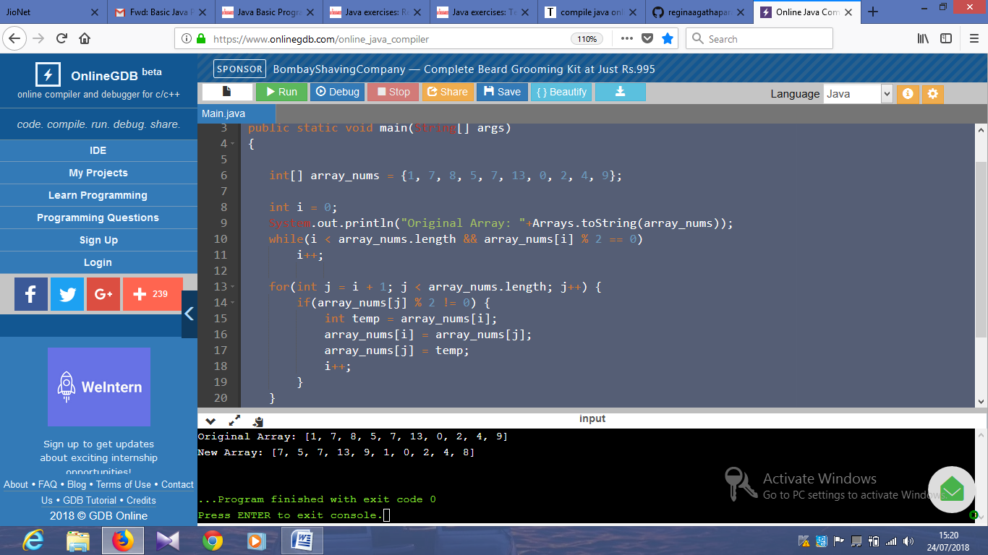

import java.util.*;

public class Main {

public static void main(String[] args)

{

int n= 5;

String[] arr_string = new String[n];

for(int i = 0; i < n; i++)

arr_string[i] = String.valueOf(i);

System.out.println("New Array: "+Arrays.toString(arr_string));

}

}

Output:

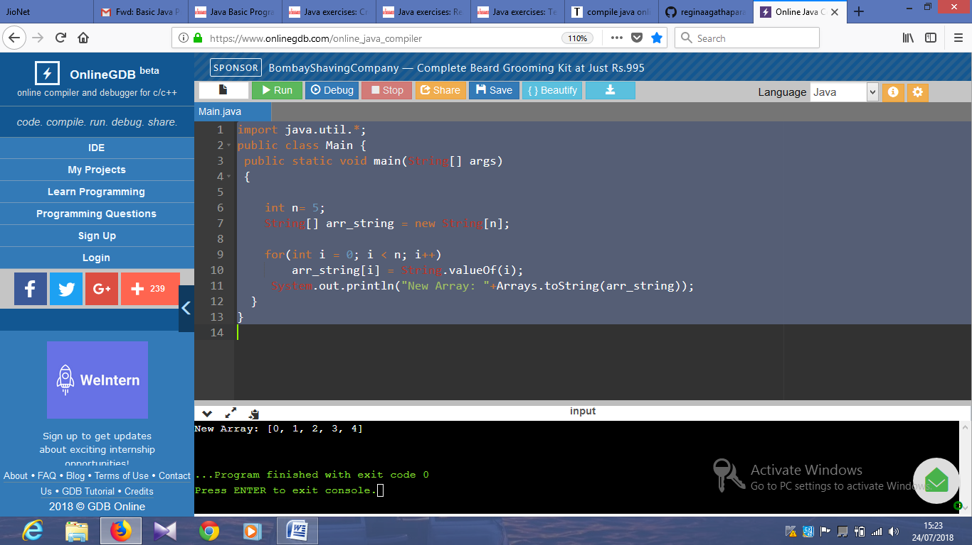

import java.util.*;

public class Main {

public static void main(String[] args)

{

int[] array_nums = {10, 20, 10, 50, 20, 13, 50};

//int[] array_nums = {10, 10, 50, 50, 20, 13, 50};

boolean testd = false;

int result=0;

int x = 10;

for(int i = 0; i < array_nums.length - 1; i++) {

if(array_nums[i] == x && array_nums[i+1] == x)

{

System.out.printf( String.valueOf(true));

result = 1 ;

}

if(i <= array_nums.length - 3 && array_nums[i] == x && array_nums[i+2] == x)

{

System.out.printf( String.valueOf(true));

result = 1 ;

}

}

if (result==0)

{

System.out.printf( String.valueOf(false));

}

System.out.printf("\n");

}

}

Output:

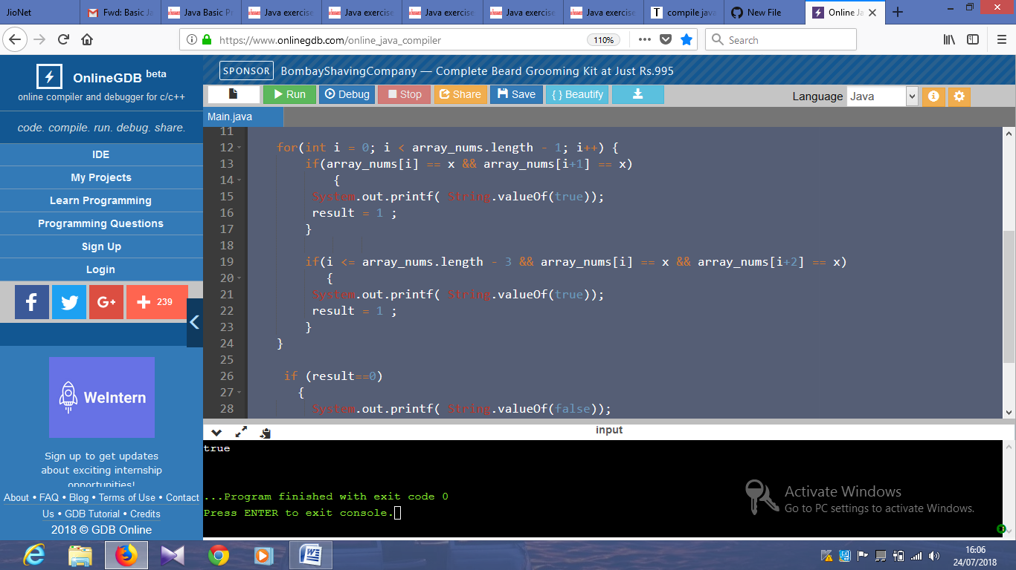

import java.util.*;

public class Main {

public static void main(String[] args)

{

int[] array_nums = {10, 20, 10, 20, 40, 13, 20};

int count = 0, result =0;

if(array_nums.length >= 1 && array_nums[0] == 20)

count++;

for(int i = 1; i < array_nums.length; i++) {

if(array_nums[i - 1] == 20 && array_nums[i] == 20)

{

System.out.printf( String.valueOf(false));

result = 1;

}

if(array_nums[i] == 20)

count++;

}

if (result==0)

{

System.out.printf( String.valueOf(count == 3));

}

System.out.printf("\n");

}

}

Output:

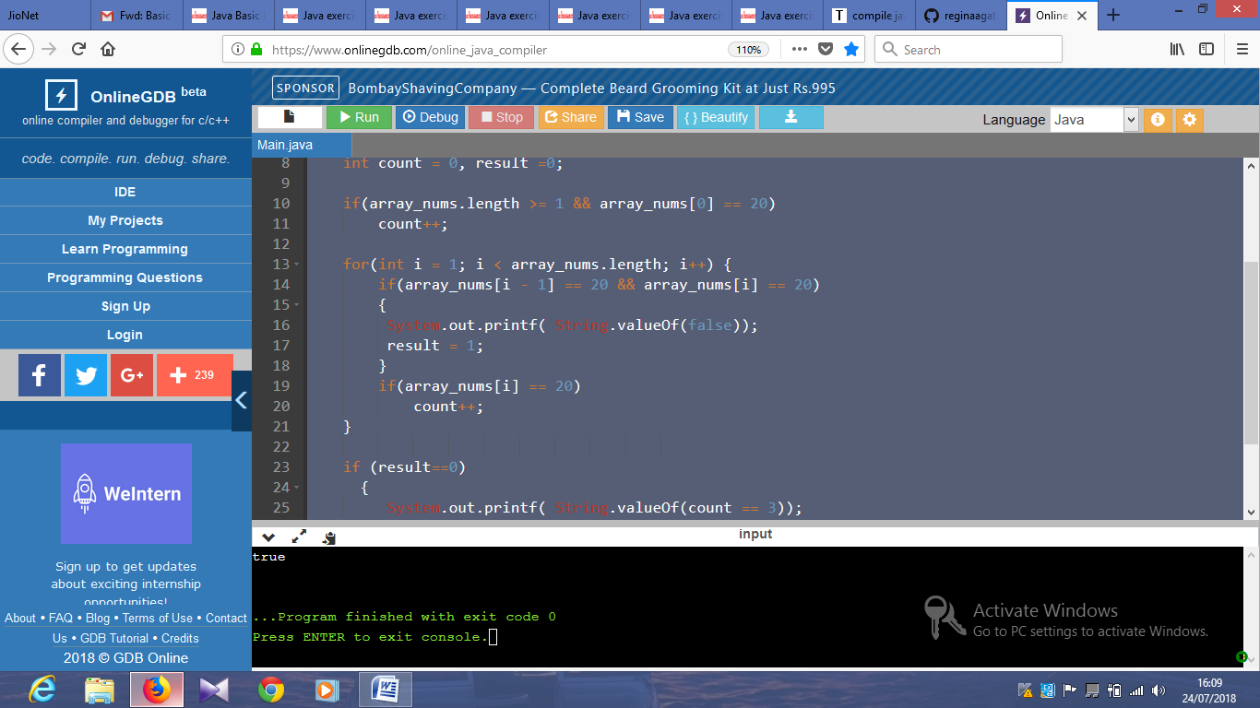

import java.util.*;

public class Main {

public static void main(String[] args)

{

int[] array_nums = {10, 20, 10, 20, 40, 20, 50};

int result = 0;

int x = 20;

for(int i = 0; i < array_nums.length - 1; i++) {

if(array_nums[i] != x && array_nums[i + 1] != x)

{

result = 1;

}

}

if (result==0)

{

System.out.printf( String.valueOf(true));

}

else

{

System.out.printf( String.valueOf(false));

}

}

Output;

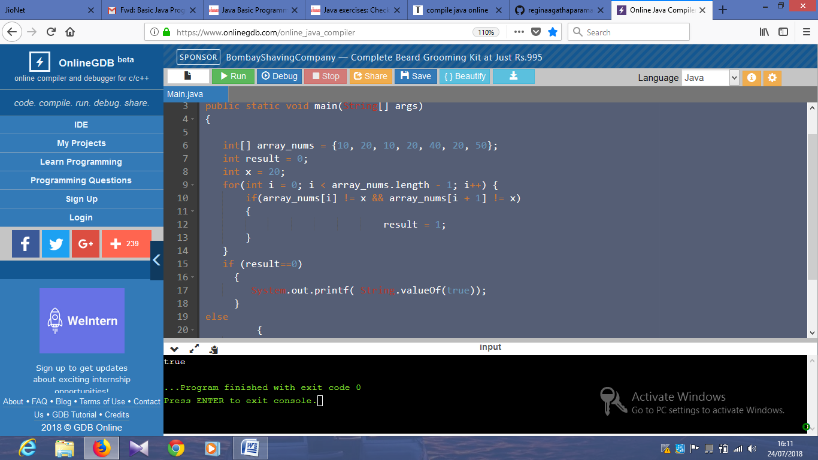

import java.util.*;

public class Main {

public static void main(String[] args)

{

int[] array_nums = {10, 11, 10, 30, 45, 20, 33, 53};

int result = 0;

System.out.println("Original Array: "+Arrays.toString(array_nums));

int ctr1 = 0;

int ctr2 = 0;

for(int i = 0; i < array_nums.length; i++) {

if(array_nums[i] == 10)

ctr1++;

if(array_nums[i] == 20)

ctr2++;

}

System.out.printf(String.valueOf(ctr1 > ctr2));

System.out.printf("\n");

}

}

Output:

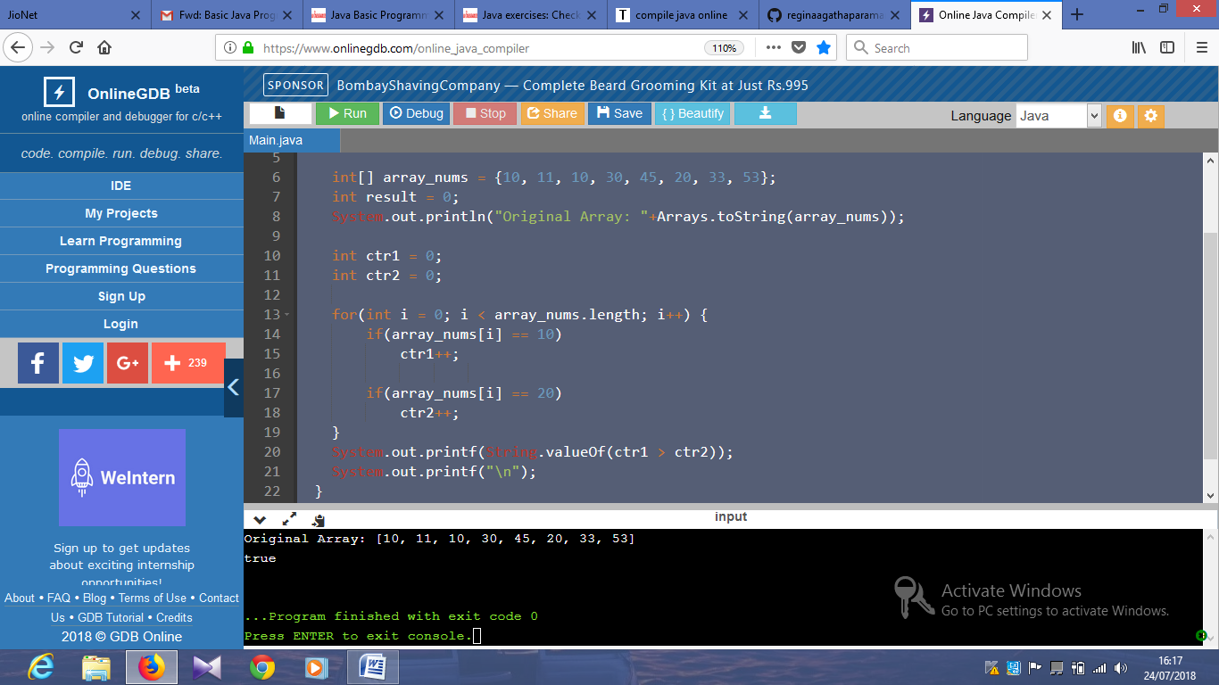

import java.util.*;

public class Main {

public static void main(String[] args)

{

int[] array_nums = {11, 11, 13, 31, 45, 20, 33, 53};

int result = 1;

System.out.println("Original Array: "+Arrays.toString(array_nums));

for(int i = 0; i < array_nums.length; i++)

{

if(array_nums[i] == 10 || array_nums[i] == 30)

{

result =0;

}

}

if (result==1)

System.out.printf( String.valueOf(false));

else

System.out.printf(String.valueOf(true));

}

}

Output:

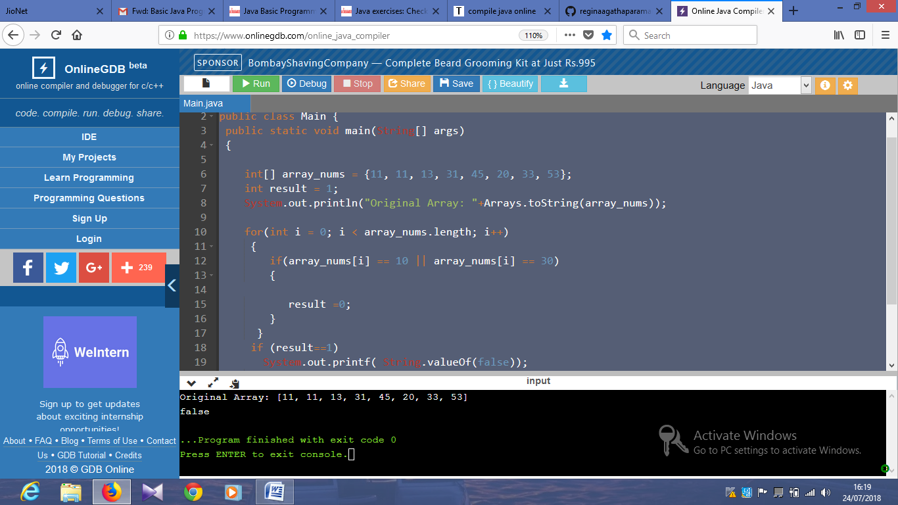

import java.util.*;

public class Main {

public static void main(String[] args)

{

int[] array_nums = {11, 10, 13, 10, 45, 20, 33, 53};

int result = 0;

System.out.println("Original Array: "+Arrays.toString(array_nums));

int l = array_nums.length - 1;

int[] new_array;

while(array_nums[l] != 10)

l--;

new_array = new int[array_nums.length - 1 - l];

for(int i = l + 1; i < array_nums.length; i++)

new_array[i - l - 1] = array_nums[i];

System.out.println("New Array: "+Arrays.toString(new_array));

}

}

Output:

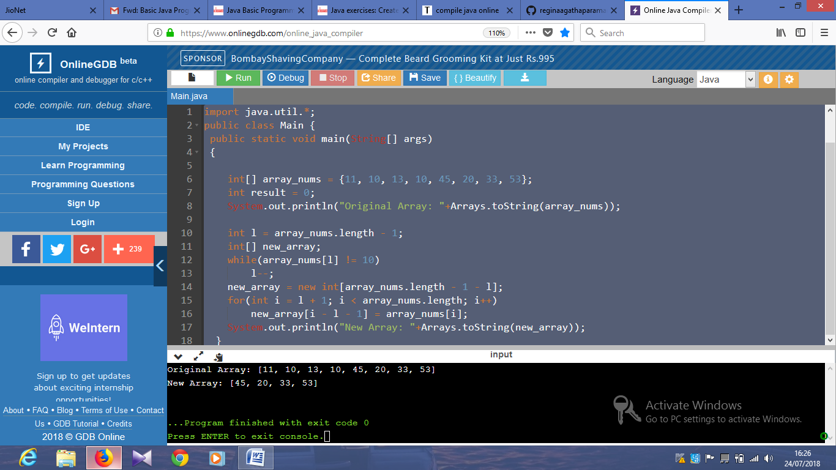

import java.util.*;

public class Main {

public static void main(String[] args)

{

int[] array_nums = {11, 15, 13, 10, 45, 20, 33, 53};

int result = 0;

System.out.println("Original Array: "+Arrays.toString(array_nums));

int l = 0;

int[] new_array;

while(array_nums[l] != 10)

l++;

new_array = new int[l];

for(int i = 0; i < l; i++)

new_array[i] = array_nums[i];

System.out.println("New Array: "+Arrays.toString(new_array));

}

}

Output:

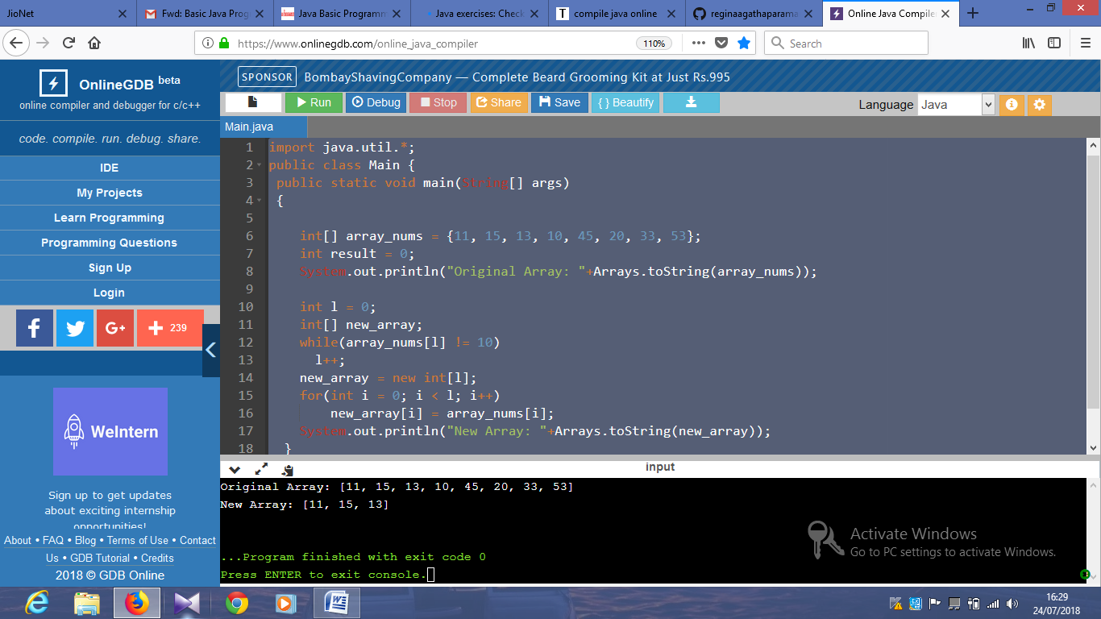

import java.util.*;

public class Main {

public static void main(String[] args)

{

int[] array_nums = {11, 15, 13, 10, 45, 20, 11, 15};

System.out.println("Original Array: "+Arrays.toString(array_nums));

int result = 0;

int l = 2;

int start = 0;

int end = array_nums.length-l;

for(; l > 0; l--)

{

if(array_nums[start] != array_nums[end])

result = 1;

else

{

start++;

end++;

}

}

if (result==1)

{

System.out.printf(String.valueOf(false));

}

else

{

System.out.printf(String.valueOf(true));

}

System.out.printf("\n");

}

}

Output:

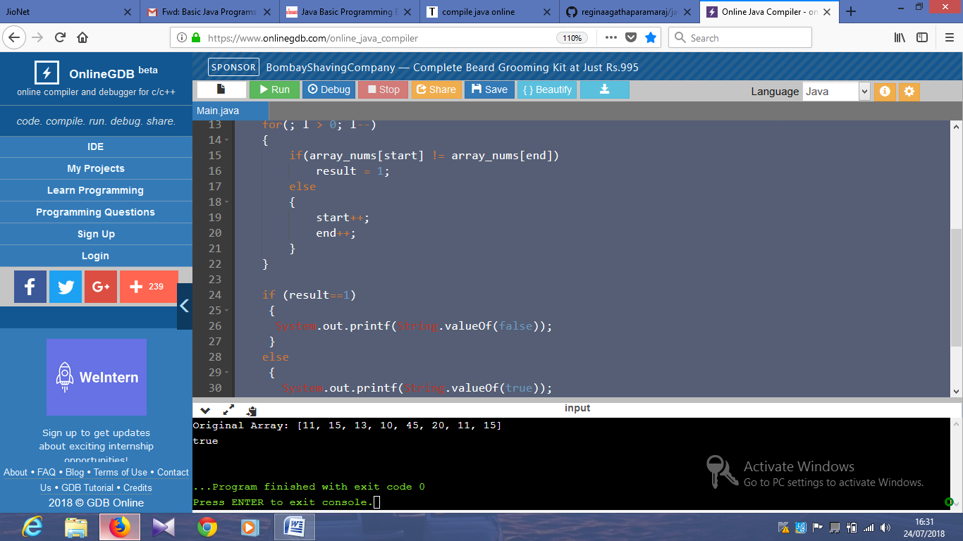

import java.util.*;

import java.io.*;

public class Main

public static void main(String[] args)

{

int[] array_nums = {11, 15, 13, 10, 45, 20};

System.out.println("Original Array: "+Arrays.toString(array_nums));

if(array_nums.length >1)

{

int first = array_nums[0];

for(int i = 1; i < array_nums.length; i++)

array_nums[i - 1] = array_nums[i];

array_nums[array_nums.length - 1] = first;

System.out.println("New Array: "+Arrays.toString(array_nums));

}

}

}

}

import java.util.*;

import java.io.*;

public class Main{

public static void main(String[] args)

{

int[] array_nums = {11, 12, 13, 14, 45, 20};

System.out.println("Original Array: "+Arrays.toString(array_nums));

int result =1;

for(int i = 0; i <= array_nums.length - 3; i++) {

if(array_nums[i] + 1 == array_nums[i+1] && array_nums[i+1] + 1 == array_nums[i+2])

result =0;

}

if (result==1)

{

System.out.printf(String.valueOf(false));

}

else

{

System.out.printf(String.valueOf(true));

}

System.out.printf("\n");

}

Ouput:

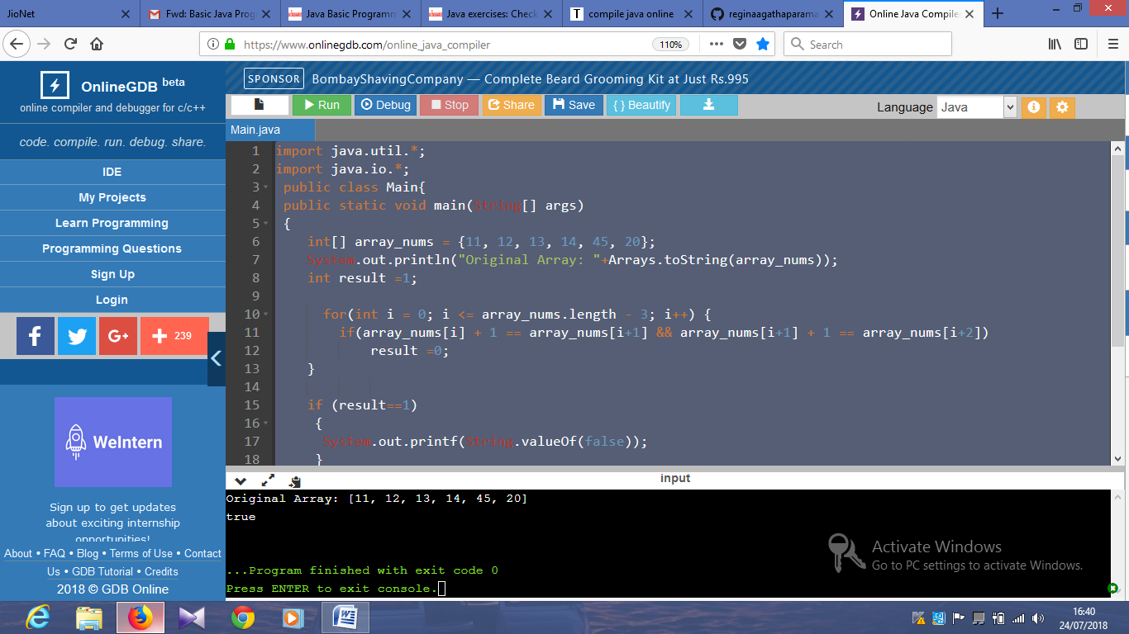

import java.util.*;

import java.io.*;

public class Main{

public static void main(String[] args)

{

Scanner in = new Scanner(System.in);

System.out.print("Input a positive integer: ");

int n = in.nextInt();

if (n>0)

{

System.out.print("The single digit number is: "+(n == 0 ? 0 : (n % 9 == 0 ? 9 : n % 9)));

}

System.out.println("\n");

}

}

Output:

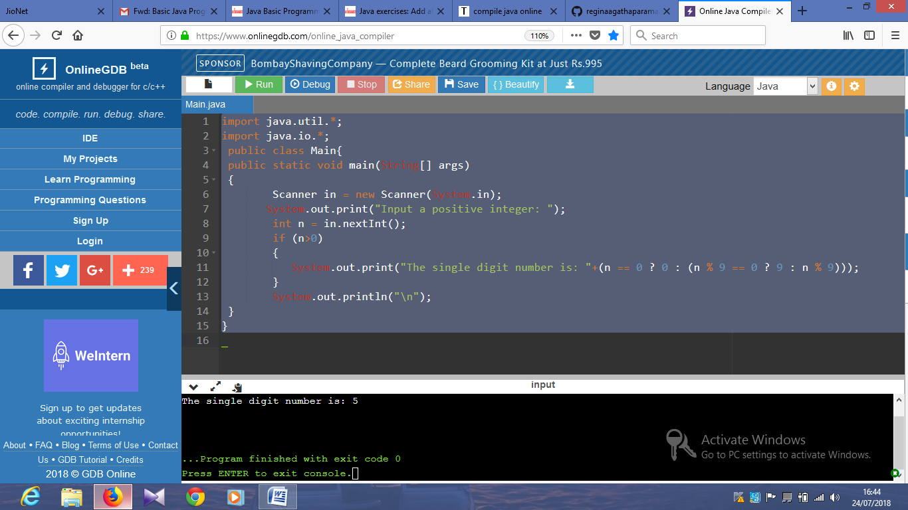

import java.util.*;

import java.io.*;

public class Main{

public static void main(String[] args)

{

int test = 0;

Scanner in = new Scanner(System.in);

System.out.print("Input a positive integer: ");

int n = in.nextInt();

if (n < 1) {

System.out.print(Boolean.toString(false));

test = 1;

}

if ((n & (n - 1)) != 0) {

System.out.print(Boolean.toString(false));

test = 1;

}

if (test==0)

{

System.out.print(Boolean.toString((n & 0x55555555) != 0));

}

System.out.print("\n");

}

}

Output:

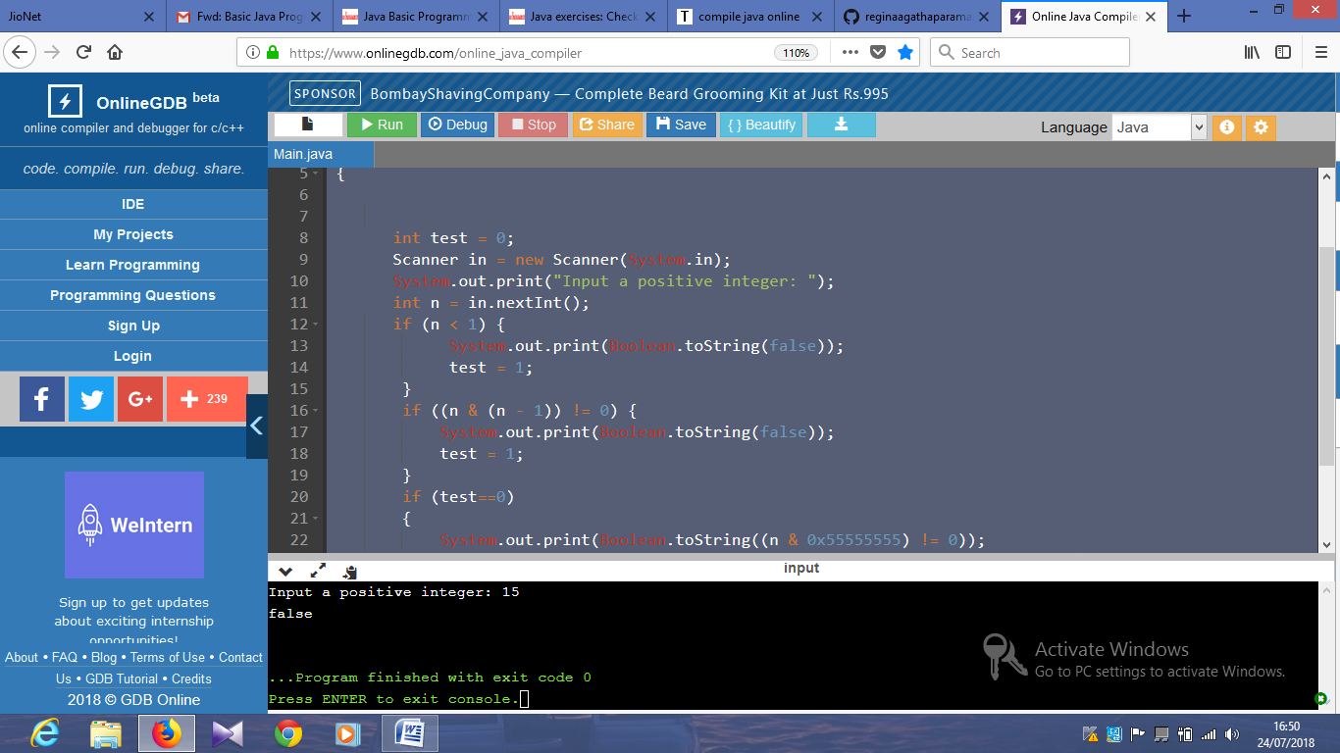

import java.util.*;

import java.io.*;

public class Main{

public static void main(String[] args)

{

int x, y ;

Scanner in = new Scanner(System.in);

System.out.print("Input first number: ");

x = in.nextInt();

System.out.print("Input second number: ");

y = in.nextInt();

while(y != 0){

int carry = x & y;

x = x ^ y;

y = carry << 1;

}

System.out.print("Sum: "+x);

System.out.print("\n");

}

Output:

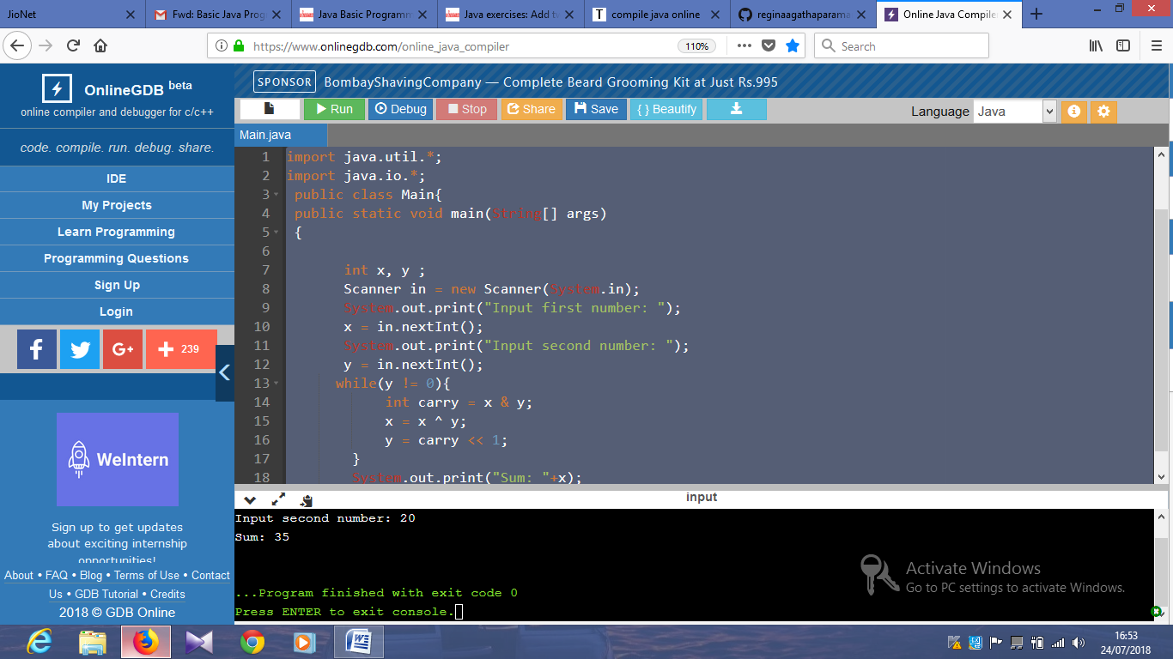

import java.util.*;

import java.io.*;

public class Main{

public static void main(String[] args)

{

Scanner in = new Scanner(System.in);

System.out.print("Input a number: ");

int n = in.nextInt();

int n1 = n;

long ctr = 0;

while (n != 0)

{

ctr += n / 5;

n /= 5;

}

System.out.printf("Number of trailing zeros of the factorial %d is %d ",n1,ctr);

System.out.printf("\n");

}

}

Output:

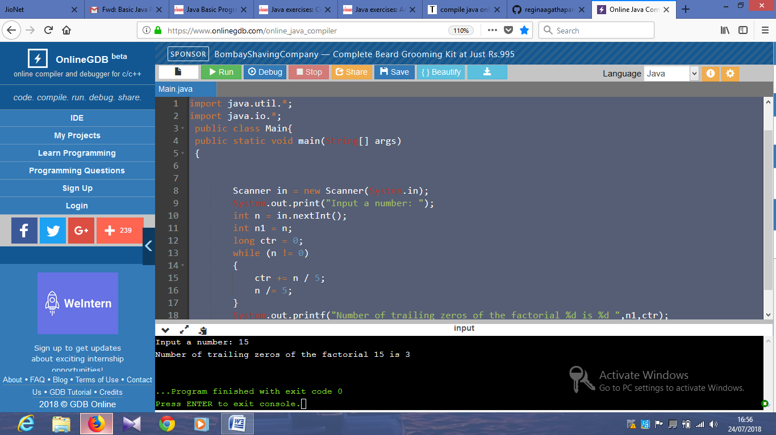

import java.util.*;

import java.io.*;

public class Main{

public static void main(String[] args)

{

// Sorted integer array array1 which has m elements,

// but size of array1 is m+n, sorted integer array array2 which has n elements

//declaration and instantiation.

int array1[]=new int[8];

//initialization.

array1[0]=1;

array1[1]=2;

array1[2]=3;

array1[3]=4;

int[] array2 = {2,5,7,8};

System.out.println("\nArray1: "+Arrays.toString(array1));

System.out.println("\nArray2: "+Arrays.toString(array2));

int m =4, n=4;

int i = m-1, j = n-1, index = m + n - 1;

while (i >= 0 && j >= 0) {

if (array1[i] > array2[j]) {

array1[index--] = array1[i--];

} else {

array1[index--] = array2[j--];

}

}

while (i >= 0) {

array1[index--] = array1[i--];

}

while (j >= 0) {

array1[index--] = array2[j--];

}

System.out.println("\nMerged array: "+Arrays.toString(array1));

}

}

Output:

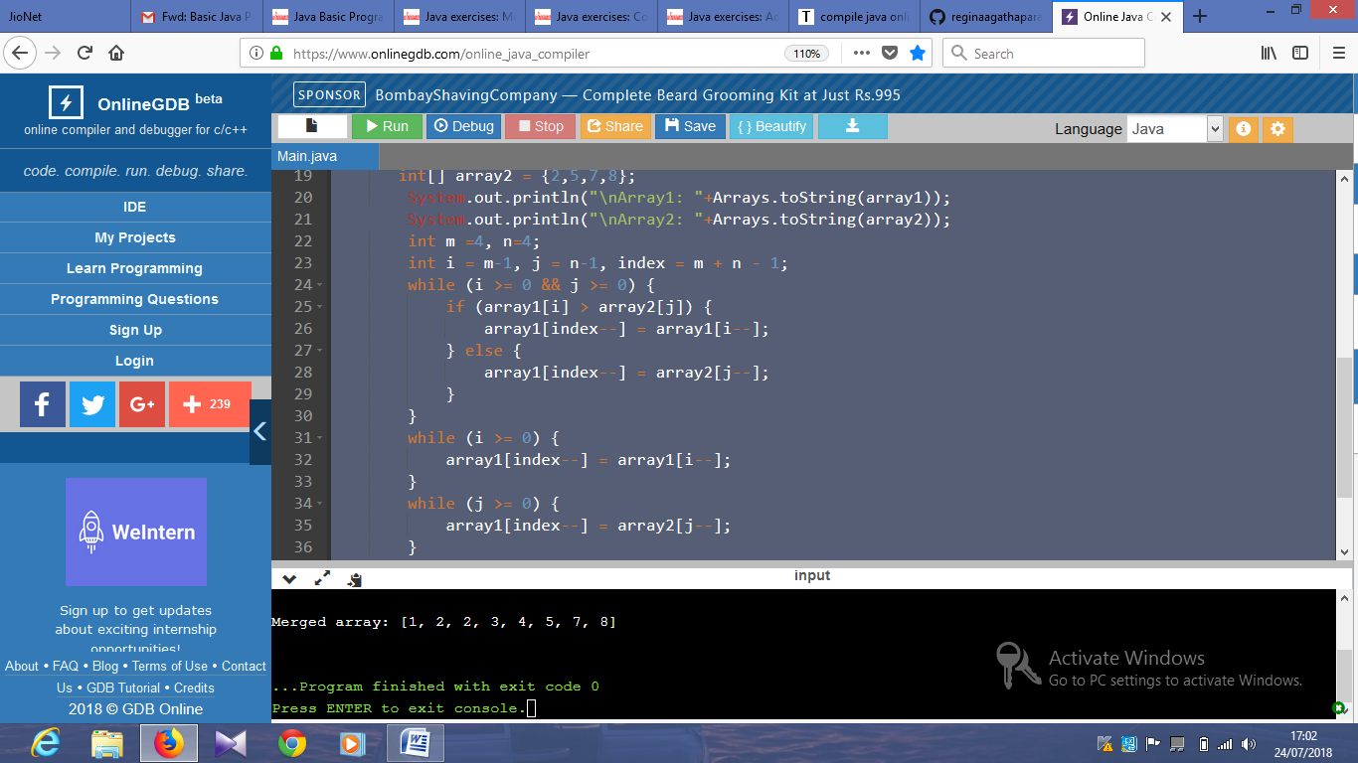

import java.util.*;

import java.io.*;

public class Main{

public static void main(String[] args)

{

String str = "abcdef";

char[] A = str.toCharArray();

int offset=3;

int len = A.length;

offset %= len;

reverse(A, 0, len - offset - 1);

reverse(A, len - offset, len - 1);

reverse(A, 0, len - 1);

System.out.println("\n"+Arrays.toString(A));

}

private static void reverse(char[] str, int start, int end) {

while (start < end) {

char temp = str[start];

str[start] = str[end];

str[end] = temp;

start++;

end--;

}

}

}

Output:

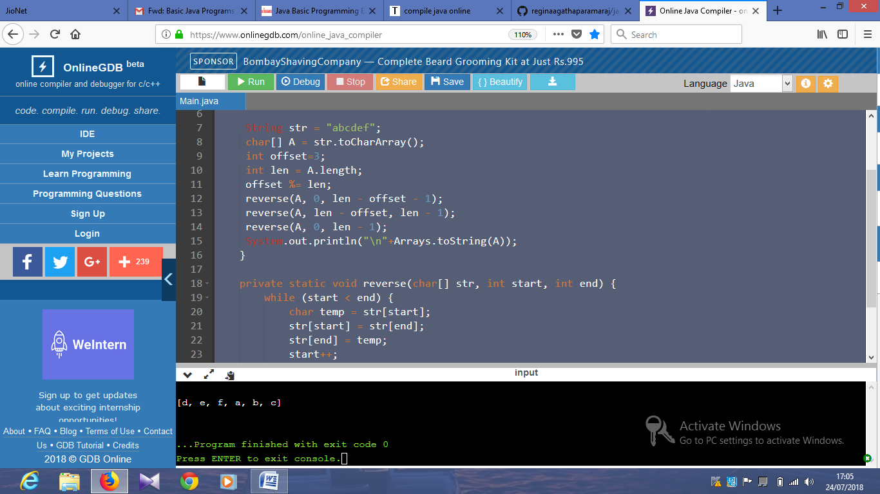

import java.util.*;

import java.io.*;

public class Main{

public static void main(String[] args)

{

int num;

Scanner in = new Scanner(System.in);

System.out.print("Input a positive integer: ");

int n = in.nextInt();

System.out.printf("Is %d is a palindrome number?\n",n);

System.out.println(palindrome(n));

}

private static boolean palindrome(int num) {

String str = String.valueOf(num);

int i = 0;

int j = str.length() - 1;

while (i < j) {

if (str.charAt(i++) != str.charAt(j--)) {

return false;

}

}

return true;

}

}

Output:

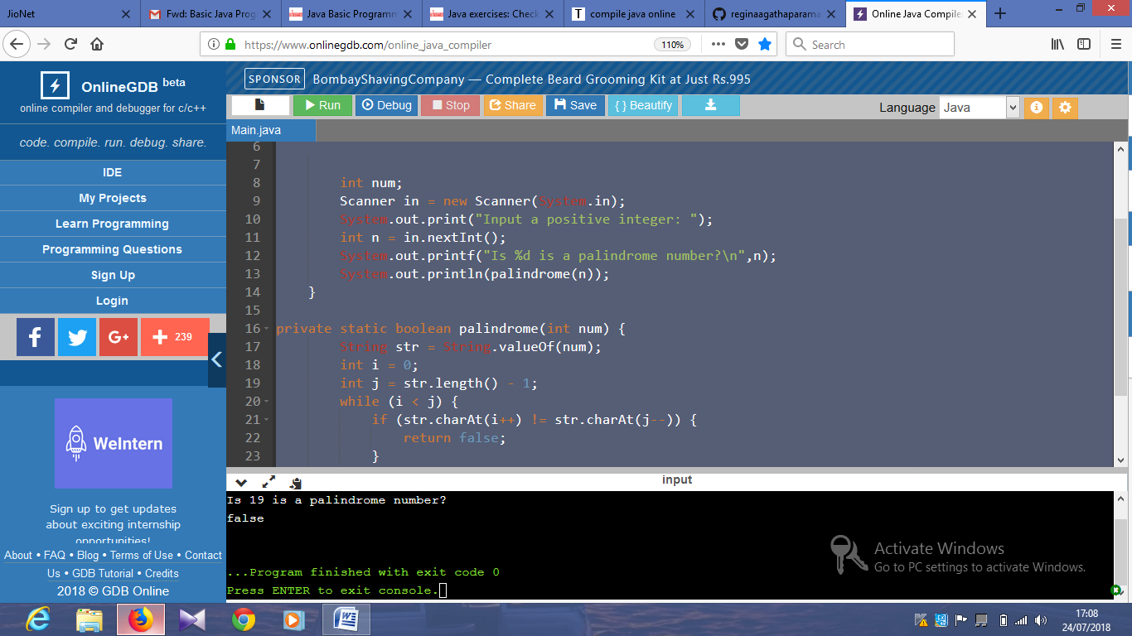

import java.util.*;

import java.io.*;

public class Main{

public static void main(String[] args)

{

for (int i = 1; i <= 100; i++) {

if (i % 3 == 0 && i % 5 == 0) {

System.out.printf("\n%d: fizz buzz",i);

} else if (i % 5 == 0) {

System.out.printf("\n%d: buzz",i);

} else if (i % 3 == 0) {

System.out.printf("\n%d: fizz",i);

}

}

System.out.printf("\n");

}

}

Output:

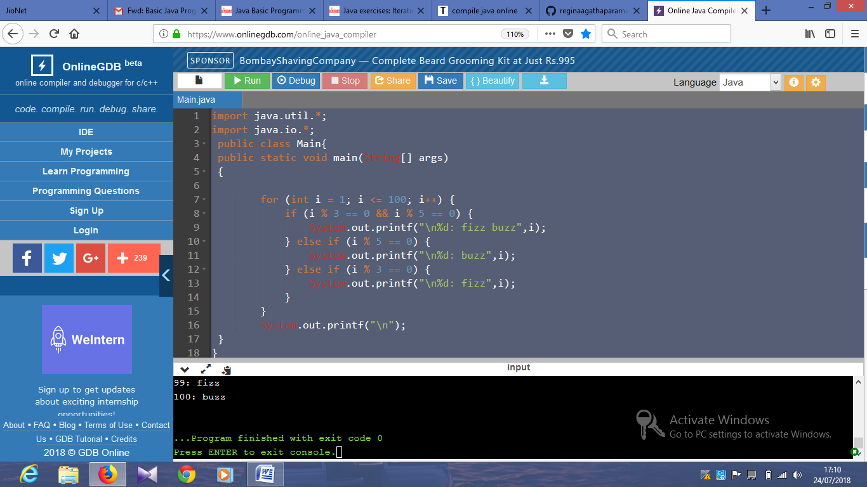

import java.util.*;

import java.io.*;

public class Main{

public static void main(String[] args)

{

int num;

Scanner in = new Scanner(System.in);

System.out.print("Input a positive integer: ");

int n = in.nextInt();

System.out.printf("Square root of %d is: ",n);

System.out.println(sqrt(n));

}

private static int sqrt(int num) {

if (num == 0 || num == 1) {

return num;

}

int a = 0;

int b = num;

while (a <= b) {

int mid = (a + b) >> 1;

if (num / mid < mid) {

b = mid - 1;

} else {

if (num / (mid + 1) <= mid) {

return mid;

}

a = mid + 1;

}

}

return a;

}

}

Output:

